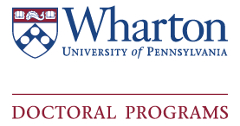
Language Testing Form

Under the laws of the Commonwealth of Pennsylvania, all prospective teaching assistants who will teach undergraduates and whose native language is other than English must undergo an evaluation of their ability to communicate in spoken English before they can undertake teaching responsibilities. This includes U.S. citizens, prospective ITAs who have matriculated from other institutions of higher education in the United States and/or who may also have teaching experience in English (For details, see section VI.H. of the Handbook for Faculty and Academic Administrators ).

In order to best assist the Doctoral Program Office determine who is eligible to opt-out of the Speak Test, please check of any statements that apply to you:

□ I am a US citizen with *native fluency in English
□ I have scored a 27/30 on the speaking portion of the TOEFL Exam and can provide the scores to the university

□ I have achieved a superior rating on the ACTFL and can provide the scores to the university

□ I do not meet any of this criteria

Name: _______________________________ Date: ______________________
Department: _________________________ Penn ID: ______________________

*Native speakers are considered anyone who began using English fluently during elementary school – anyone who began using English beyond that time is considered a non-native speaker

Upon completion, please return this form to Gidget Murray in the Wharton Doctoral Office: gmurray@wharton.upenn.edu
If you have any questions regarding the requirements or exceptions for the Speak Test, please contact elp@sas.upenn.edu or 215-898-8681.

